*Project 1- State-Wise Development Analysis In India*

Step 1:  
I have downloaded the file: StatewiseDistrictwisePhysicalProgress.xml

Then using flume I copy the file from local system to hdfs:  


And Output:  
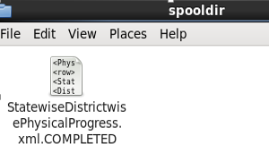

Step 2.1:  
1st Problem to find out total which is 100% BPL:

PigScript:  
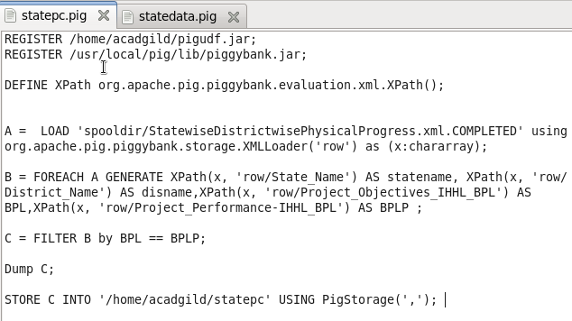

Output:

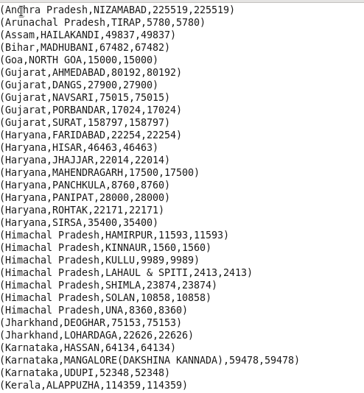

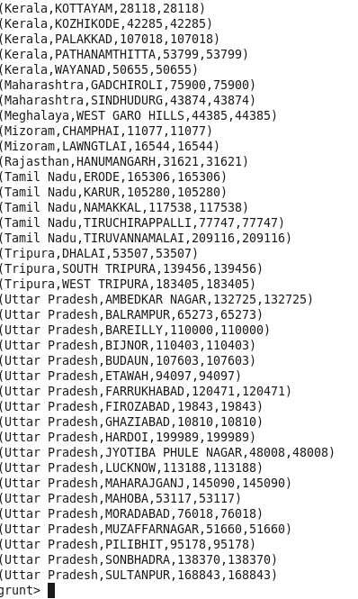

Storing the result into RDBMS using Sqoop :



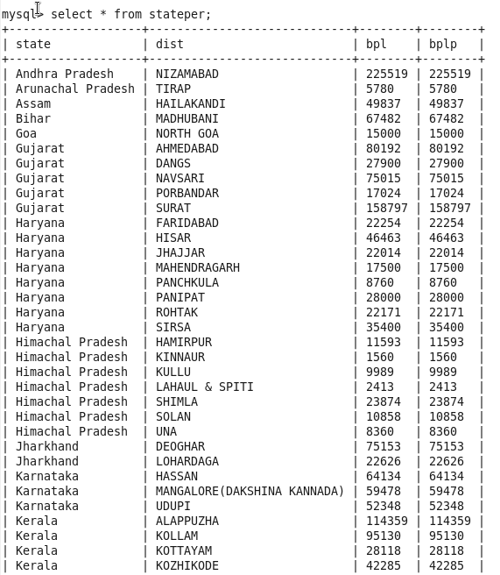

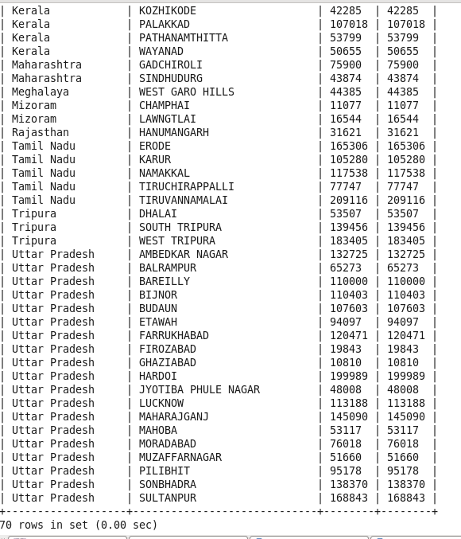

Step 2.2:  
2nd Problem to find out data greater than 80% using Pig UDF:

Created .jar named percent.jar:  
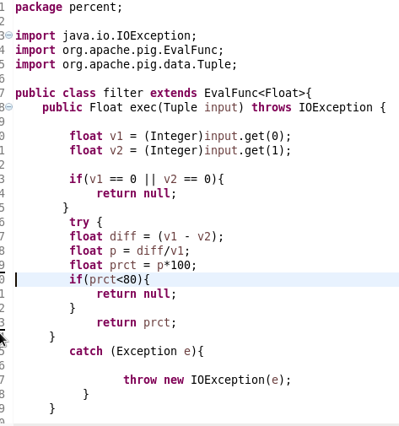

Then ran the below script and stored as statepc1:  
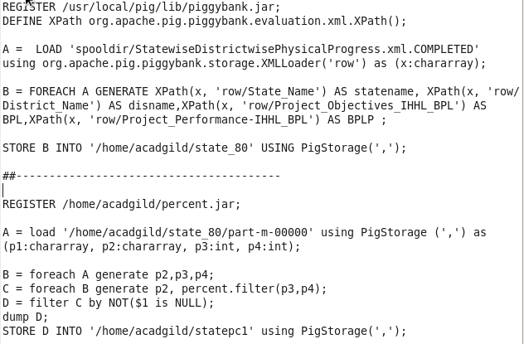

Then received the below output:

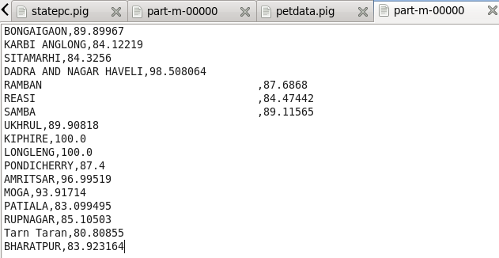

Storing data into RDBMS by running Sqoop:



